SCOPE CLUB
(School of Programming Excellence)
MLRIT Main Website - Club Page Content Submission

Official Club Name
SCOPE Club - It is a student-led technical community at MLR Institute of Technology, focused on coding, problem-solving, innovation, and continuous technical growth.

Updated Club Logo

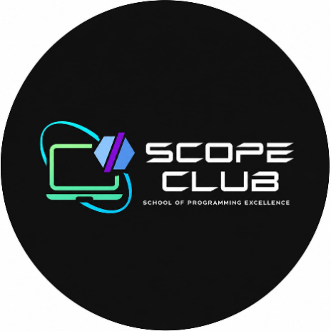

Vision / Tagline

“Turning coding passion into real projects and meaningful experiences through collaboration, guidance, and hands-on learning.”
SCOPE is a space where students can learn, explore, and build together. The club encourages students to explore areas such as AI, open source, web and app development, game development, and other emerging technologies. Through technical sessions, workshops, events, mentorship, and projects, SCOPE helps students gain practical skills, work on their ideas, and grow together as a technical community.

About the Club

SCOPE Club at MLR Institute of Technology is a student-led technical community built around coding, curiosity, problem-solving, and learning by doing. The club goes beyond regular classroom learning by giving students opportunities to explore technology, learn from their peers, and turn what they learn into practical skills.

A big part of SCOPE is peer-to-peer learning. Initiatives like SCOPE Sessions give students a chance to learn coding concepts, improve their technical skills, and get practical guidance from fellow students.

What makes SCOPE unique?

What makes SCOPE different is its student-driven approach. It is not just about conducting events, the club focuses on creating opportunities, projects, and platforms that students can continue to benefit from even after an event is over.

One example is CodeStats, a platform built by SCOPE members. It started as a way for students to track their coding progress across different programming platforms and later grew to include DSA practice and problem-solving. It now helps students improve their coding skills and prepare for technical interviews and placements.

Purpose of the Club

SCOPE gives students a place to learn, explore, and work with technology beyond the classroom. The club focuses on practical learning, problem-solving, and giving students the chance to turn their ideas into real projects while getting familiar with new technologies and industry practices.

Key Objectives

Help students improve their coding and problem-solving skills through regular practice and activities.

Encourage students to learn by doing through projects, workshops, hackathons, and competitions.

Give students a space to try out their ideas, experiment, and build useful solutions.

Encourage students to learn from and work with each other through teamwork and knowledge sharing.

Help students explore new and emerging technologies and understand how they are used in real life.

Support students in preparing for competitions, internships, placements, and future opportunities.

Encourage students to build useful projects and platforms that can benefit the college community and future students.

Activities & What Happens in the Club

SCOPE conducts different technical activities throughout the year that give students opportunities to learn new technologies, improve their skills, work with others, and take part in technical challenges.
- Technical Workshops & Training
- SCOPE conducts workshops and training sessions on areas such as:
- Coding and programming
- Web and application development
- Cloud computing and AWS
- Emerging technologies
- Industry-related technical topics
- These sessions include practical activities that help students understand concepts and get experience working with different technologies.
- Coding & Technical Competitions
Students are encouraged to take part in coding contests, competitive programming challenges, hackathons, and other technical competitions. These activities give students a chance to practice problem-solving and apply their technical knowledge in a competitive setting.
- Innovation & Project Development
SCOPE encourages students to work on technical projects and turn their ideas into working solutions. Activities include web and application development, game development, hackathon projects, and other student-led projects.
- SCOPE Sessions :-
SCOPE Sessions are peer-learning sessions where students get the opportunity to learn technical topics from their seniors and fellow students. These sessions can cover coding concepts, tools, technologies, and other topics that students may find useful outside their regular coursework.
The sessions also give students a chance to ask questions, discuss concepts, and learn from someone who has already worked with the topic. This makes SCOPE Sessions an important part of the club's focus on learning together.
- Career & Industry Exposure
The club also conducts career-oriented sessions and technical talks that introduce students to current technologies, industry expectations, and different career paths in technology. Students get opportunities to interact with industry professionals and learn from their experiences.
- Knowledge Sharing & Community Learning
Learning at SCOPE is not limited to workshops and competitions. Students share their knowledge through student-led sessions, peer learning, and team-based activities. Seniors and peers can share their experience, help others with technical concepts, and work together on projects and challenges.
- Notable Projects Developed
SCOPE members have worked on projects such as Code Stats, giving students an opportunity to apply their technical knowledge while building practical solutions.
- Achievements & Recognition
SCOPE teams have also participated in Jatayu and have achieved notable results across its seasons. The team has been a finalist for two seasons and was the runner-up in the most recent season.
- Recognition
SCOPE's activities and participation in technical events have helped the club build a strong presence within the student community. Through its sessions, projects, competitions, and other activities, the club continues to provide students with opportunities to learn, participate, and gain practical experience.

Events to Be Conducted

Major events conducted / planned by the club (tentative calendar for Academic Year 2026–2027):
Event Name | Date | Target Participants
Zenith’26 | Dec 17,18&19th 2026 | All Over India

Flagship / Star Events
  - Zenith’25
Note: The above schedule is tentative and may be subject to changes.
  - Init Saga
  - Zenith’24
  - Webmania 2.0
  - Splash
  - GameHub 2.0
  - Modifest
  - CBUG Contest
  - GameHub
  - Codewars

Star Events Posters:

  - Zenith’25
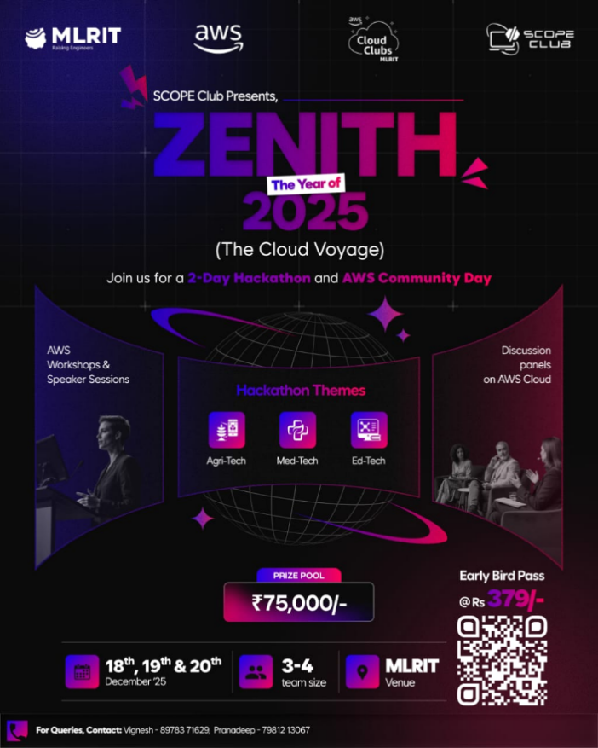

- Event Photos & Videos
Zenith’25
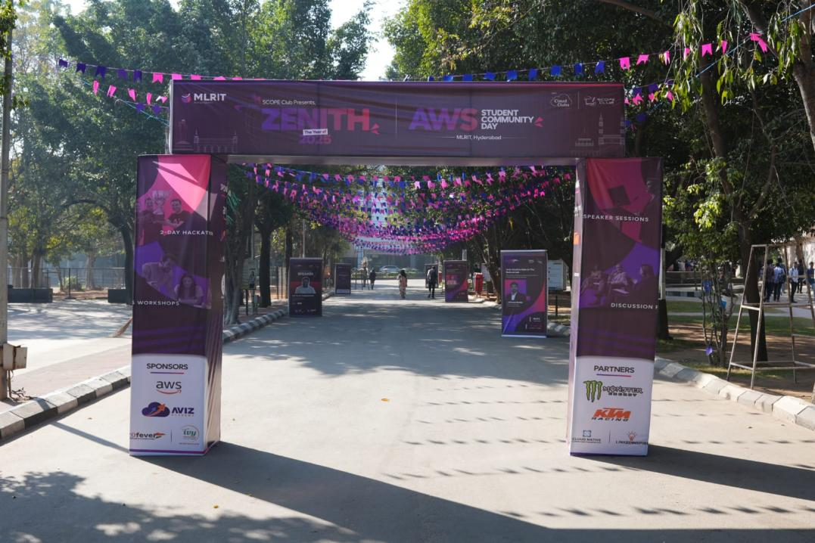
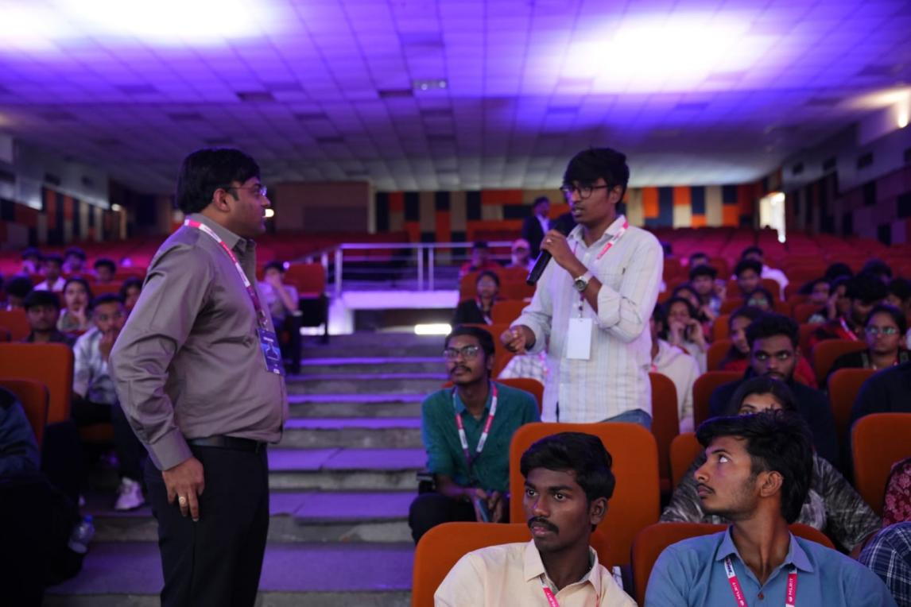
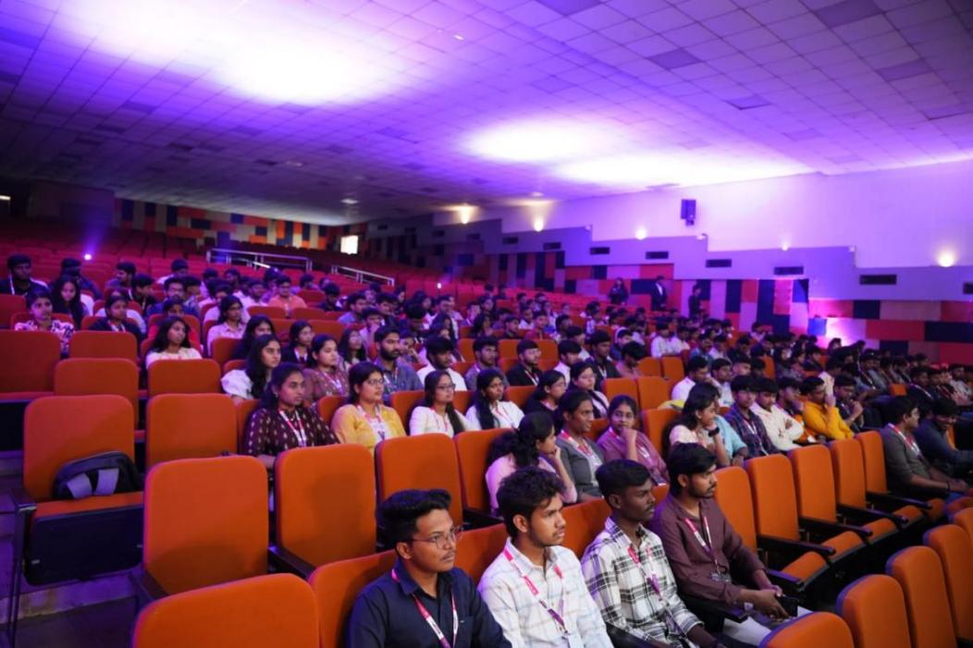
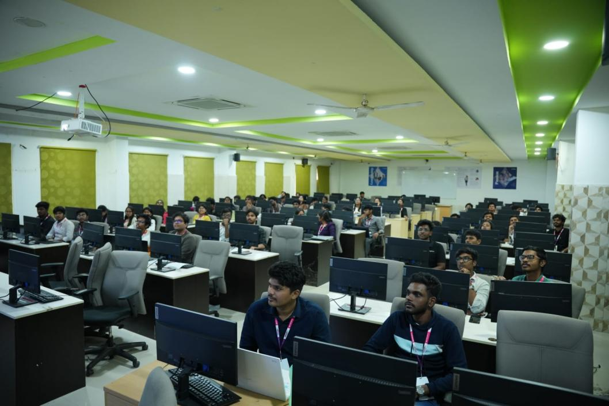
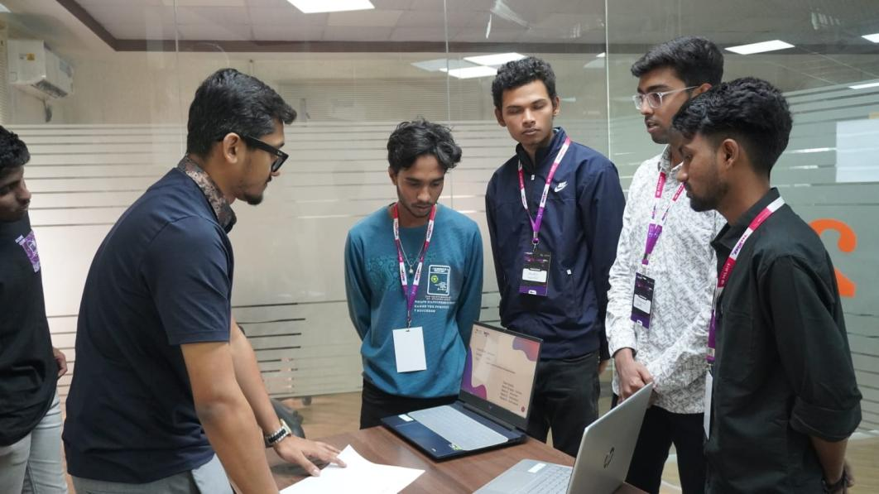
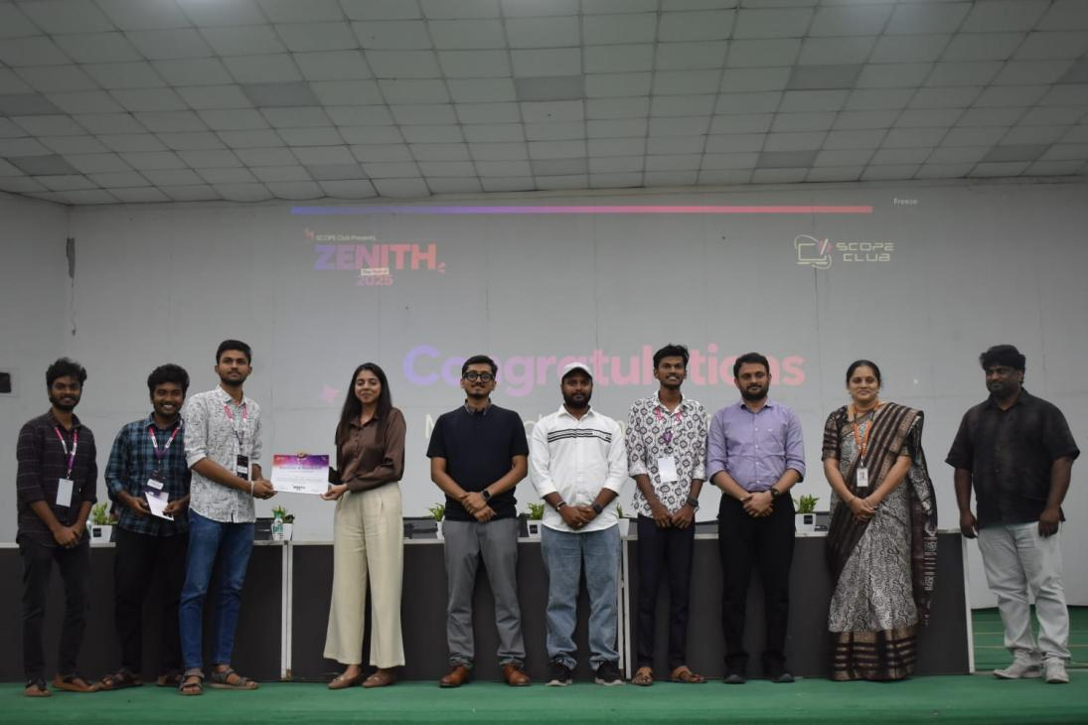

- Club Website / Online Presence
Instagram: mlrit_scope
LinkedIn: mlrit-scope
Individual Club Website:https://scopeclub.vercel.app/

